**Tanta University**

**College of engineering**

**Department of electronics and communication systems**

**A New Method for Measuring Tremor and Related Disabilities in the Elderly Using Accelerometers**

**Supervised by:**

**Prof. Ameira Ashour**

**Eng. Mina**

**A New Method for Measuring Tremor and Related Disabilities in the Elderly Using Accelerometers**

Prepared for

Prof. **Ameira Ashour**

Head of the Department of electronics and communication systems

**Prepared by**

|  |  |
| --- | --- |
| الاسم | رقم الكشف |
| إبراهيم محمد راشد المزين sec 4 | **1** |
| ابراهيم محمد محمد الجوهري sec 2,2.1 | **2** |
| احمد إبراهيم زكريا العضامي project | **3** |
| احمد السيد حسن كليب project | **4** |
| احمد جمال عبدالعظيم العياد sec 3.1 | **5** |
| احمد ربيع عبدالرحمن عبدالرحمن sec 5 | **6** |
| احمد سلام احمدي ابوالسيد project | **7** |
| احمد صلاح عبدالعزيز العشماوي project | **8** |
| احمد عمر إبراهيم أبوالعنين sec 1, sec7 | **9** |
| احمد محمد على عبدالبر sec 3 | **10** |

Undergraduate students

Department of electronics and communication systems

April 16, 2024

April 16. 2024

Dear Prof. **Ameira Ashour**,

Department of Electronics and Communication Systems

This is a report that you inquired about a specific instrument used in the medical domain. We chose to implement an accelerometer measurement device with some digital processing techniques to extract the frequencies inside the acceleration data. The power spectrum is particularly useful in diagnosing tremor diseases that do exist in the elderlies. However, diagnosing using accelerometers and the spectrum content is still not employed due to the absence of a standard protocol to measure the tremor using accelerometers. Etienne et al [2] proposed a protocol to measure the tremor using accelerometers and the acceleration power spectrum density as a standard for measuring tremors. Measuring tremors is done by subjective ways, so using measurement tools to objectively measure tremor enable the medical community to further classify tremor diseases, diagnose them more efficiently and help in accessing their case and proper treatment for them.

We used Arduino uno and accelerometer sensor module (MPU-6050) to measure the acceleration along 3-axis (X, Y and Z). The acceleration data was uploaded onto a computer device on which the data was further processed. The processing was done using a python program which consisted of the Fast Fourier Transform (FFT). FFT was used to extract the spectrum of acceleration data. Unfortunately, we did not collect data from real tremor patients due to the lack of resources and time but, we would like to in the future. The follow up sections of the report include details about tremor and the protocol proposed to objectively measure it. It also includes specifications about our project regarding the accelerometer sensor as a measuring tool for quantifying tremors.

**Table of Contents**

1. **Introduction………………………………………………………………page 5**
2. **Tremors……………………………………………………………………page 6**

**2.1. Causes of Tremors ……………………………………………page 6**

**3- Acceleration Measurement of Tremors………………………page 7**

**3.1 Proposed Measurement Protocol (Our Experiment section included here)……………………………………………………..page 9**

**4- Arduino Uno Accelerometer Project…………………………..page 10**

**5-Accelerometer Results………………………………………………...page 11**

**6-Future Work……………………………………………………………….…page 15**

**7-Conclusion………………………………………………………………….…page 16**

**8-References…………………………………………………………………...page 17**

**1.Introduction**

Tremors, the involuntary rhythmic oscillations of body parts, have plagued humanity for centuries. These uncontrollable movements not only disrupt daily activities but also pose a significant diagnostic and therapeutic challenge. Traditionally, the medical field has relied on visual observation – a subjective and potentially inaccurate method – to assess tremors. However, recent advancements in technology offer a promising alternative: acceleration measurement using accelerometers.

This report embarks on a deep dive into the realm of tremor analysis using accelerometers. It delves into the very nature of tremors, exploring their classification, causes, and the limitations of current assessment methods. The report then unveils the power of accelerometers, meticulously dissecting the principles behind this technology and its suitability for tremor quantification.

Moving beyond theoretical concepts, the report presents a standardized measurement protocol that integrates accelerometry with established clinical assessments. This meticulous approach ensures data integrity and facilitates objective analysis. The report then delves into the practical implementation, showcasing the design and construction of an Arduino Uno-based tremor measurement system. Paired with Python for data processing, this system offers a practical and accessible solution for tremor assessment.

To validate the system's effectiveness, the report explores the evaluation process using simulated signals. A critical analysis of the results, including any limitations encountered, provides valuable insights into the system's capabilities and potential areas for improvement.

The report concludes by peering into the future, exploring potential applications of accelerometry in tremor analysis. It discusses how this technology can revolutionize various aspects of tremor management, from facilitating early and accurate diagnosis to monitoring treatment effectiveness and paving the way for the development of novel therapies.

This comprehensive exploration aims to establish accelerometry as a game-changer in the field of tremor assessment. By providing a more objective and quantitative approach, this technology holds immense promise for improving patient care and enhancing the quality of life for individuals living with tremors.

**2.Tremors**

Tremors are characterized by uncontrollable, rhythmic muscle contractions that result in shaking movements in one or more body parts. These involuntary movements can create substantial inconvenience and interfere with daily life. Tremors are most observed in the hands, arms, head, legs, trunk, and even the voice. Tremors are broadly classified into two primary categories: resting tremors and action tremors. Understanding the characteristics of each type can provide insights into diagnosis and treatment options[2].

● **Resting Tremors:**

○ Occur when the affected body part is completely supported and at rest.

○ Often observed in association with Parkinson's disease.

● **Action Tremors:**

○ Manifest themselves during voluntary movement of the affected body part.

○ Further subdivided into the following subtypes:

■ **Postural Tremor:** Emerges when a person maintains a position against gravity, such as holding their arms outstretched.

■ **Kinetic Tremor:** Appears during any voluntary movement, such as reaching for an object.

■ **Intention Tremor:** Worsens as the person approaches a target, such as during a finger-to-nose test.

**2.1. Causes of Tremors**

The precise causes of many tremors often remain unidentified. However, a range of potential causes and contributing factors have been recognized, including:

● **Neurological Disorders**: Conditions like Parkinson's disease, multiple sclerosis, stroke, and traumatic brain injuries can disrupt the parts of the brain responsible for regulating movement.

● **Genetic Predisposition:** Certain tremors, such as essential tremor, display a pattern of familial inheritance.

● **Medications:** Some medications have the potential to induce tremors as an adverse side effect.

● **Substance Use:** Alcohol use disorder, alcohol withdrawal, and excessive caffeine consumption can contribute to tremors.

**3.Acceleration Measurement of Tremors**

Acceleration measurement of tremors plays an important role in various fields, notably seismology, engineering, and healthcare. Tremors, often associated with seismic activities or physiological conditions like Parkinson's disease, manifest as involuntary rhythmic movements. Accurate measurement and analysis of tremors' acceleration provide valuable insights into their characteristics, facilitating diagnosis, treatment, and risk assessment. Wearable accelerometers track tremors' intensity, frequency, and duration, assisting physicians in tailoring treatment plans and evaluating patients' response to therapy[2].

Tremors, the involuntary shaking of a body part, have been a challenge for diagnosis and treatment for centuries. Traditionally, doctors have relied on visual observation to assess tremors, but this approach can be subjective and inaccurate**.** In recent years, a new approach has emerged: acceleration measurement. By attaching tiny sensors called accelerometers to the affected body part, researchers and clinicians can now capture objective data about the tremor's:

* **Severity**: How much force is exerted during the shaking.
* **Frequency**: How often the tremor occurs per second.
* **Pattern**: The specific way the tremor moves the limb.

This information provides a more quantitative understanding of tremors, allowing for:

* **Improved diagnosis**: Differentiating between different types of tremors and underlying conditions.
* **Better treatment monitoring**: Tracking the effectiveness of medications or therapies.
* **Development of new treatments**: By providing a more precise target for interventions.

Essential Tremor (ET) is a common clinically diagnosed involuntary movement disorder with an estimated prevalence of **0.5%** overall and **5%** in people over the age of **65** . ET can be sporadic or have a familial genetic component. The frequency of postural limb tremor in ET varies between **4** and **12** Hz and is typically between **4** and **6** Hz. ET is usually bilateral and may have a prominent kinetic component. Rest tremor is more characteristic of Parkinson’s disease. ET can cause significant incapacity especially during fine motor tasks. The pathophysiology of ET remains unclear[2].

In the research setting, an important initial step to characterizing an oscillation such as in ET is to measure its power spectrum.

* **Power spectrum is a crucial tool for analyzing tremors (like in Essential Tremor or ET).**
* **It offers a quantitative measurement of tremor strength across different frequencies.**
* **Compared to subjective visual scales used by healthcare professionals, power spectra from sensors provide more objective data with continuous values.**
* **This data can be incredibly useful for tracking individual patient progress, evaluating treatment responses (drugs, deep brain stimulation, or surgeries like thalamic lesions).**

A roadblock for the widespread use of the power spectrum in evaluation of tremor in clinical practice is the lack of reliable and standardized methods for acquisition and analysis. For example, results may vary with the anatomical site of transducer placement, type of sensor, whether acquisition is done in a structured clinical exam setting, duration of sampling, potential fluctuations during longer-term spontaneous recording, or variations in spectral analysis. Here, Etienne Gauthier-Lafreniere presents a method that integrates accelerometry with a standardized clinical assessment protocol.

* **Accelerometer wristwatches can record tremors during specific postures, like a clinical tremor exam.**
* **A standardized protocol ensures consistent data collection.**
* **A user-friendly MATLAB framework analyzes the recordings and provides:**
  + **Acceleration power spectrum of the tremor**
  + **Peak frequency**
  + **Peak power**
  + **Total power**

In our project we used a Python program instead of the MATLAB program they used in the paper. This tremor analysis method is tested on patients with postural and action tremors (diagnosed with ET) who are considering surgery[2].

The new method using accelerometers is validated:

* **It detects the different tremor types (postural, action, rest).**
* **It correlates well with CRST scores.**
* **Power spectra provide more precise details on tremor frequency and severity**.

The authors propose this approach using wristwatch accelerometers, standardized exams, and user-friendly software as a valuable tool for:

* **Quantifying tremor with continuous data.**
* **Analyzing tremors from different causes in older patients.**
* **Applying it in various clinical and research settings**.

**3.1 Proposed Measurement Protocol**

The acquisition protocol proposed by Etienne et al[2] a method for recording tremors in patients using wristwatch accelerometers. Various procedures must be followed to ensure that the data collected will not be wrong and not represent the tremor. The protocol can be summed up in the next points:

* **Participant Preparation**: Patients diagnosed with Essential Tremor (ET) were off ET-related medication, caffeine, and alcohol for 12 hours before the test. They also removed any upper limb jewelry.
* **Accelerometry Equipment**: The study used laboratory-grade wristwatches with MEMS-based accelerometers, which are capable of continuous data recording. The data was extracted and converted for analysis using specific software.
* **Recording Protocol**: Patients were seated comfortably with their arms in various positions: resting, extended, bimanual extension, wing position, and action with loading. Each position was held for 30 seconds with 30-second rest intervals. A light sensor in the wristwatch marked the start and end of each tremor recording epoch.
* **Data Analysis**: The recorded data was downloaded and processed using a MATLAB application developed for automated data analysis. The application provided a user-friendly interface for characterizing tremor associated with each limb position.
* **Clinical Correlation**: Alongside accelerometry, patients’ tremors were assessed using the Clinical Rating Scale for Tremor (CRST) by a physician during the same session. This allowed for time-matched comparisons between the objective accelerometry data and the subjective clinical assessment.

This standardized protocol aimed to provide robust and repeatable tremor recordings that could be easily analyzed and integrated into clinical evaluations. The method was validated in a cohort of patients with postural and action tremor diagnosed with ET. In our experiment:

* We used a python program for data analysis instead of the MATLAP program.
* We also recorded the data over a period of 10 seconds instead of 30 seconds.
* Due to the lack of actual patients, the recordings were done on one of us who made voluntary movements with his hand to stimulate the tremors.
* Once the program starts, it pauses for 5 seconds before starting to acquire the data to give enough time for preparing.

**4.Arduino Uno Accelerometer project**

Using the commercial microcontroller [Arduino Uno](https://docs.arduino.cc/resources/datasheets/A000066-datasheet.pdf) and an accelerometer module ([MPU-6050](https://www.yic-electronics.com/datasheet/66/112467.pdf))[1], we were able to build an acceleration sensor. The Acceleration module measures the acceleration along the primary three axis. This module is also able to function as a gyroscope that measures the angular position changes. However, we are only interested in measuring the acceleration data along the three axes. It is worth mentioning that the gyroscope data would be useful to measure tremors related to rotational motion of the limbs. The Baud-rate was set to 9600 which is a rate sufficient for the application at hand. The computer program receives a data point from the acceleration sensor each 1ms, while the spectrum of tremors does not exceed 10hz. This rate of taking samples is much than enough for such a purpose. Figure 1 and figure 2 below show a picture of the microprocessor along with the acceleration sensor[4].

Figure 2 MPU 9050 Acceleration sensor

Figure 1 ARDUNIO UNO microprocessor

The acceleration sensor uses the piezoelectric effect in measuring the acceleration along the three axis. Piezoelectric materials generate a potential difference when stress is applied to them. The produced potential is proportional to the amount of stress applied to the piezoelectric material. Thus, these materials can be employed to measure stress and by extension, acceleration. Inside the sensor there are proof masses suspended on microscopic beams, these suspended masses experience acceleration due to applied forces or due to gravity. The acceleration causes the masses to press on the piezoelectric materials causing a voltage across the material. This voltage is proportional in turn to the amount of acceleration. The sensor allows a full acceleration range of ±2g, ±4g, ±8g, and ±16g where g is the acceleration due to earth gravity[1].

The received data are analyzed by a python program set on a [PC](https://www.hp.com/us-en/shop/pdp/victus-by-hp-gaming-laptop-pc-15t-fa100-156-771t0av-1#techSpecs) (click on it to view the pc specifications). As mentioned earlier the program is set to take a data sample from the accelerometer every 1ms. By this sampling rate the device could measure frequencies up to 2000hz according to the Nyquist sampling principle. After the data is transferred from the Arduino to the PC, a FFT is applied to the set of data which extracts the frequency components of from it. We ran into some problems at first while using the program for the first time. The data sent by Arduino would sometimes be corrupted. This is overcome by making the program average the previous and the next datapoints to a corrupted data point. This is in fact is effective because the acceleration signal is highly correlated in time as long as the sampling rate is higher than the changes in the acceleration signal (which it is).

A noise reduction algorithm proposed by Jincheng Fu et al[3] is the Dynamic Differential Reference algorithm (DDR). Suppose that the received data point is D and the added noise to it is N, then for two consecutive data points D1 and D2 the noise value is the same. Thus, taking the difference between two consecutive data points should eliminate the noise value and the difference between the two data points only remains. The results of using this algorithm provide great values differences between stationary state of the device and dynamic state which would ease machine learning algorithms in the next stages. However, we did not employ the DDR algorithm because it did not fit with the standard provided by Etienne et al[2].

**5.Accelerometer results**

In the study done by Etienne et al[2] involving twenty-five consecutive Essential Tremor (ET) patients, a structured protocol was successfully completed, and useful accelerometry data was acquired. The average peak tremor frequency across all positions was **4.57 ± 1.8 Hz**.Tremor characteristics were analyzed separately for different upper extremity positions assumed by patients during the structured physical examination.The average peak frequency was similar in various postural conditions:

* Extended limb (unimanual): **4.78 ± 1.23 Hz**
* Extended limb (bimanual): **4.89 ± 1.43 Hz**
* Wing position: **4.58 ± 1.35 Hz**

During action, the mean peak frequency was lower (**3.81 ± 2.02 Hz**), but the difference was not statistically significant. In contrast to frequency, the mean total power (1–20 Hz) and peak power in the power spectrum of acceleration showed significant variation across various positions. An Increase in power was noted in all static postural conditions compared to rest, consistent with the diagnosis of ET syndrome. Total and peak power of acceleration were especially accentuated in the wing position. Control participants (n = 6) without clinically detectable tremor performed a similar protocol. Mean total power of acceleration during action with loading condition in controls was **0.09 ± 0.03 m²/s⁴**, which is **21 times lower** than in ET patients. This indicates that the high level of total power during action in ET patients was mainly due to tremor oscillations rather than translational artifact from back-and-forth movement[2].

In five patients, peak power of tremor at rest exceeded the low mean value (0.024 m²/s⁴ ± 0.047, SD). Among these cases, four patients had a rest peak power/postural peak power ratio significantly less than 1, while one patient had a ratio of 1.03. Interestingly, this patient exhibited the third-highest peak power during action, despite having comparatively low power at rest and during postural conditions. o Four patients had total power at rest above the low mean (**0.11 m²/s⁴ ± 0.31, SD**). These cases were part of the group of five patients with peak tremor above the mean. Among them, two patients had a rest total power/postural total power ratio above 1. Both cases also demonstrated high power during action and were among the top four in the group of twenty-five patients. These patients with advanced ET may be classified as having an “**ET plus**” variant according to a recent consensus classification. Alternatively, they could be considered as a variant of advanced ET[2].

In our project we used simulation signals coded onto the ARDINO UNO microprocessor to make sure that the data acquisition algorithm along with the signal processing part works correctly. Three sets of signals were transmitted from the Arduino to the PC, where each signal stimulates a signal transmitted from a primary axis (x, y, and z). the signals are **sin(2*3.14*t*10)+6*cos(2*3.14*t*30)+3*sin(2*3.14*t*20)** representing the x-axis signal, **sin(2*3.14*t*10)** representing the y-axis signal and **sin(2*3.14*t*30)** representing the z axis signal. The plots of the received signal by the PC are shown below (figures 3, 4 and 5) both in the time domain and in the frequency domain. The spectrum of the signal is squared to obtain the power spectrum and the values were normalized so that the maximum amplitude would be one[4].

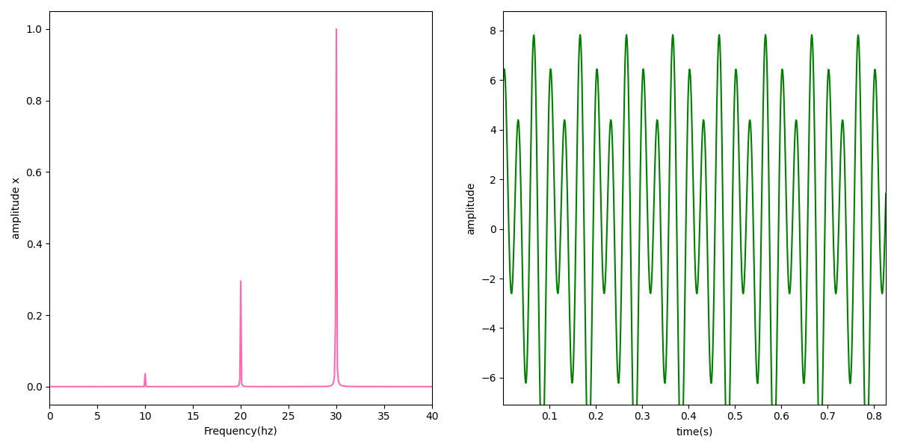

Figure 3 plot of the time and frequency domain of the simulation signal (x-axis )

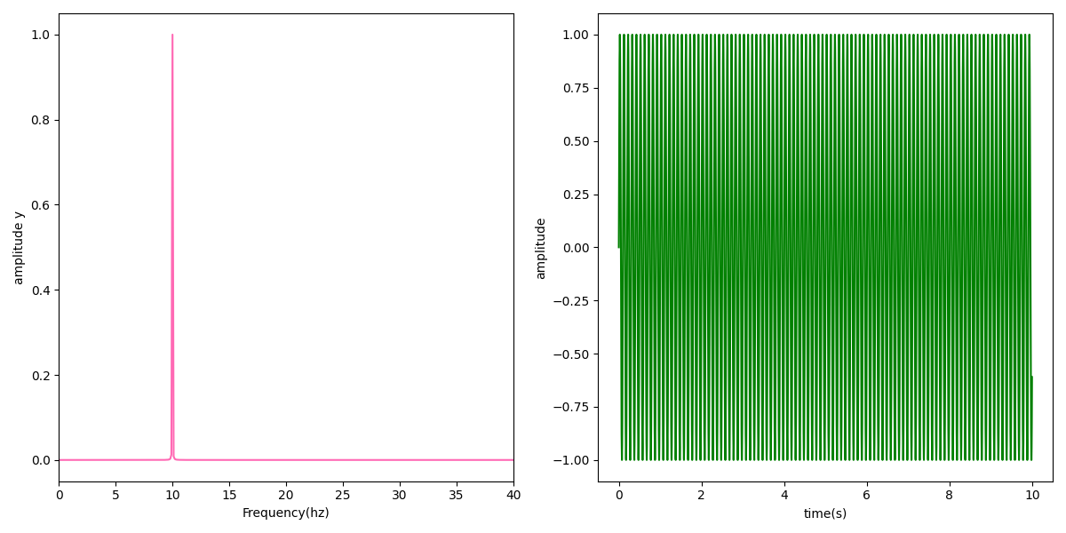

Figure 4 plot of the time and frequency domain of the simulation signal (y-axis )

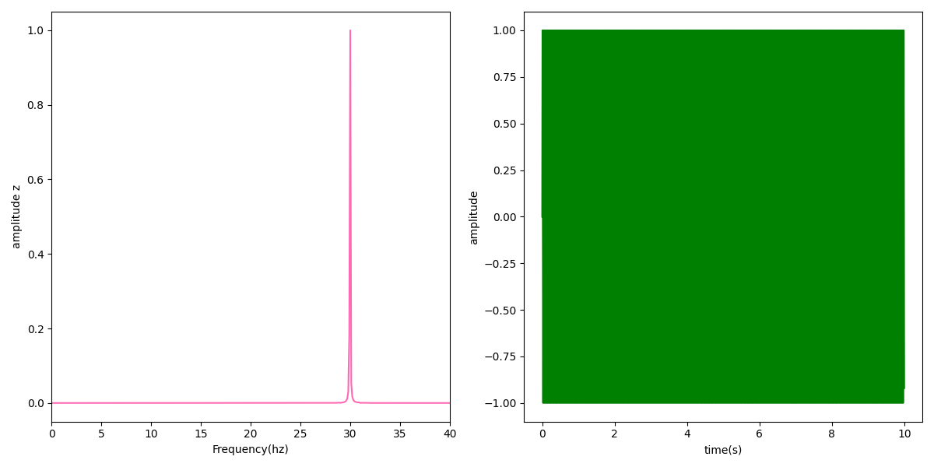

Figure 5 plot of the time and frequency domain of the simulation signal (z-axis )

The signal at the maximum frequency of the first signal is calculated by the program to be 30 Hz with an amplitude of 2.58 without normalizing. The maximum frequency of the second signal is at 10 Hz with an amplitude of 0.49 without normalization. Thus, the data obtained from the figures is consistent with the signals transmitted both in the time domain and the frequency domain[4].

The data acquired through the accelerometer are presented in the next figures (figures 6, 7 and 8). A LPF at 1 Hz and a HPF at 20 Hz are added to remove the artifacts from the signal. One artifact is the acceleration in the Z-axis imposed by the earth’s gravitational field. It appears in the spectrum around the DC component. The high frequency components also do exist due to the usual artifacts in the MPU sensor. In a normal experiment setup, many readings must be taken to evaluate the mean value of measurement and the standard deviation. However, because the data was recorded from a person that does not have any tremors the data values are insignificant. So, the measurement was taken only once to verify that the device is working correctly[4].

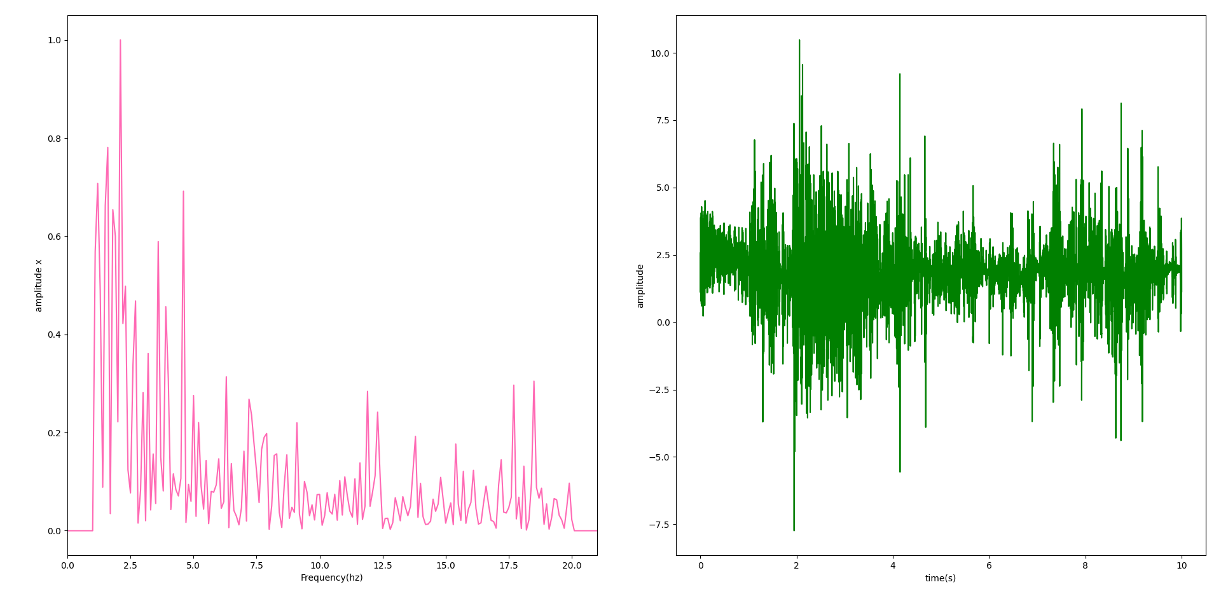

Figure 6 plot of the time and spectrum of the accelerometer data (x-axis)

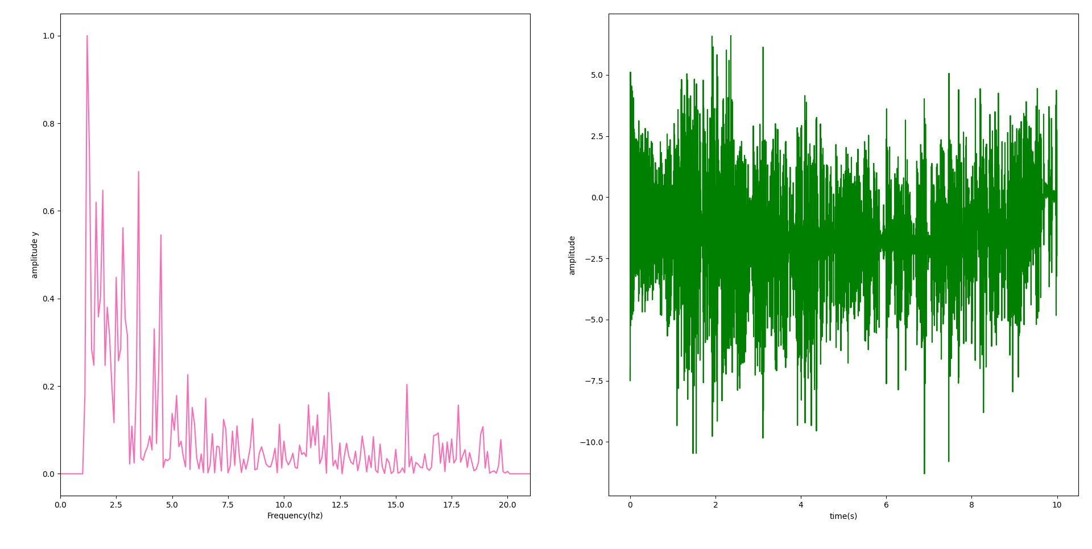

Figure 7 plot of the time and spectrum of the accelerometer data (y-axis)

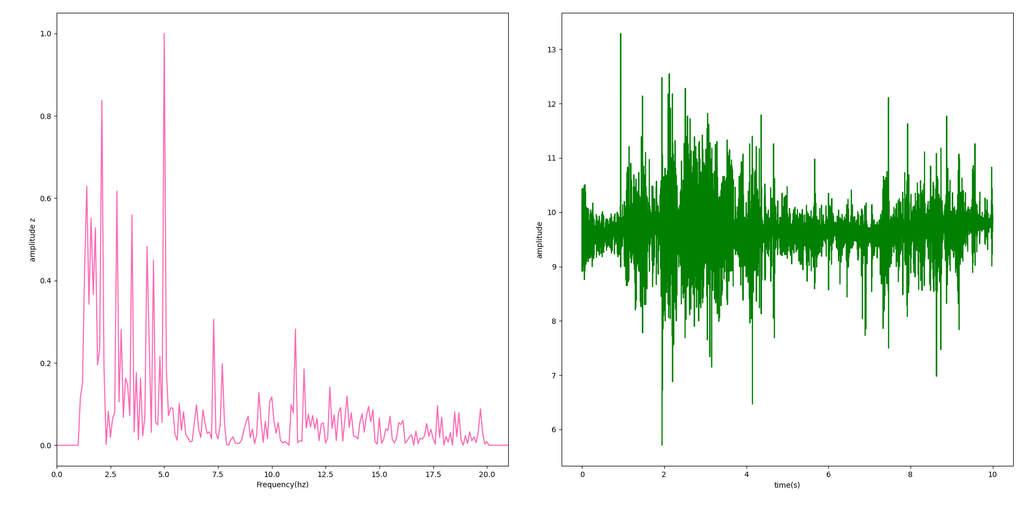

Figure 8 plot of the time and spectrum of the accelerometer data (z-axis)

The maximum frequency of the x-axis component is 2.1 Hz with unnormalized amplitude of 0.0269. The maximum frequency of the y-axis component is 1.2 Hz with unnormalized amplitude of 0.0374. the maximum frequency of the z-axis component is 5 Hz with unnormalized amplitude of 0.0101. These values are not consistent with the works of Etienne Gauthier-Lafrenier, but perhaps this is because the data was taken from a nonpatient[4].

**6. Future Work**

FFT is a fast algorithm for measuring the spectrum components of a signal, but it lacks an important aspect regarding monitoring applications. The Fourier transform has this property of obtaining a complete knowledge of the spectrum of a signal. This complete knowledge comes with a cost, the information of the temporal property of the signal is lost. For example, if a system was required to shut down completely when a certain frequency limit of a certain signal in the system is reached. The frequency limit could be obtained by applying the Fourier transform but here the question arises, at what exact moment of time did this violation occur? The answer is we cannot know for sure. In measurement applications like measuring tremors this would not cause any problem. In monitoring applications where time is a series element, this causes a significant problem. This problem is by nature a property of the universe that cannot be eliminated but we can make our way around it. Rather than obtaining complete knowledge about the spectrum of the signal, how about obtaining only significant variations in the frequency components without high frequency resolutions? This is called the wavelet transform. In the wavelet transform diagrams, time is plotted versus the frequency as shown in the following figure.

Figure 9 plot of the wavelet transform of a sinusoidal signal

This image shows the wavelet transform of a sinusoidal waveform. Regardless of the spectrum containing one frequency component, the plot does not show perfectly what the component is. This low frequency resolution enables accessing the time of a violation in the frequency spectrum shown on the time axis below. The property of knowing completely only the time or the frequency is known as the Uncertainty principle. The wavelet transform overcomes this by offering some but not complete knowledge in both domains (i.e., Decreasing the resolution). Since our device is only built for measurement purposes. only FFT is employed. For any of the readers interested in making a monitoring device out of this wavelet transform should be used.

**7.Conclusion**

This report has explored the potential of accelerometry as a transformative tool for tremor assessment. By objectively measuring tremor characteristics like severity, frequency, and pattern, accelerometers offer a significant advantage over traditional, subjective visual observation methods. The proposed measurement protocol, integrating accelerometry with established clinical assessments, provides a standardized and reliable approach for data collection. The successful implementation of an Arduino Uno-based tremor measurement system with Python data processing demonstrates the feasibility of this technology in a practical setting. The evaluation using simulated signals highlights the system's capability to capture tremor data. While limitations, such as the need for further validation with real patient data, were identified, the results are promising. Looking ahead, the potential applications of accelerometry in tremor analysis are vast. This technology can revolutionize various aspects of tremor management, including:

* **Early and Accurate Diagnosis**: Objective tremor characterization can facilitate earlier and more accurate diagnosis, leading to timely interventions and improved patient outcomes.
* **Enhanced Treatment Monitoring**: By tracking tremor severity and frequency over time, clinicians can objectively assess the effectiveness of treatment plans and adjust them as needed.
* **Development of New Therapies**: Precise tremor characterization can guide the development of targeted therapies that address the specific underlying causes of tremors.

Furthermore, the portability and affordability of accelerometers compared to traditional diagnostic tools hold promise for remote monitoring and home-based assessments, potentially improving patient access to care. In conclusion, acceleration measurement using accelerometers presents a paradigm shift in tremor assessment. This objective and quantitative approach offers significant advantages for diagnosis, treatment monitoring, and the development of novel therapies. As research progresses and technology matures, accelerometry has the potential to significantly improve the lives of individuals living with tremors.

**8.References**

**1-** [**MPU-6050 | InvenSense | IMU ACCEL/GYRO 3-AXIS I2C 24QFN | YIC Electronics**](https://www.yic-electronics.com/datasheet/66/112467.pdf)

**2-**[**Gauthier-Lafreniere, Etienne, et al. "A standardized accelerometry method for characterizing tremor: application and validation in an ageing population with postural and action tremor." Frontiers in Neuroinformatics 16 (2022): 878279.**](https://www.frontiersin.org/articles/10.3389/fninf.2022.878279/full)

**3-** [**Fu, Jicheng, et al. "A Novel Mobile Device-Based Approach to Quantitative Mobility Measurements for Power Wheelchair Users." Sensors 21.24 (2021): 8275.**](https://www.mdpi.com/1424-8220/21/24/8275)

**4-** [**The project on Git-Hub**](https://github.com/Ahmed-sallam-code/Medical-electronics-project)

**5-** [**How to process Arduino data in Python (youtube.com)**](https://www.youtube.com/watch?v=fIlklRIuXoY)